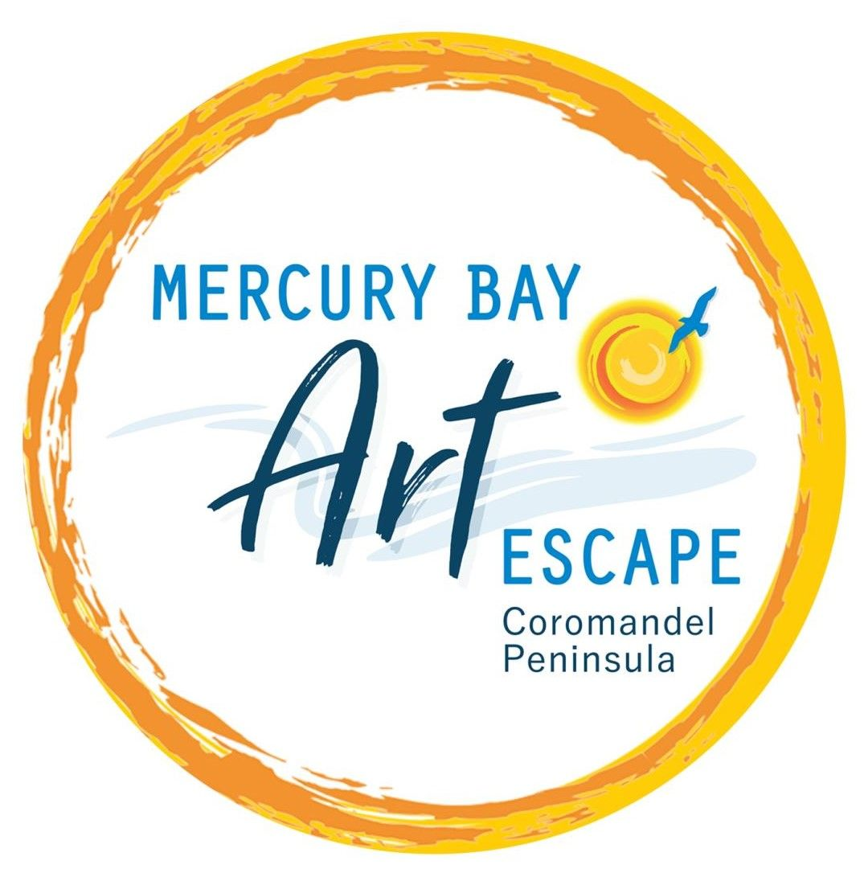
Mercury Bay Art Escape
Members/Group Renewal Form & Template for 2022/2023 website

Please complete, save as yourname.doc and upload to WeTransfer.com with your images
by 23 September 2022
Mark one box

Yes - I plan to rejoin and have read the Guidelines for Members and Groups 2023.
Yes - I plan to remain a member but not have my studio open and have read the Guidelines for Members and Groups 2023.

No - I am withdrawing - just sign and return by email

Website Information
Name
Location ie area
Media
Studio open during Open Studios | Yes or No
Artists Open Studio address |  | Post code
Contact year round
Home Phone
Mobile
Email
Artist website
Artist Facebook page
Artist Instagram page
Other artist links
Description of your work
Max 100 words written in 1st person.
Title of preferred image for Guide (subject to Designers approval)
Please upload high quality/high res jpg files, maximum 2.5MB each to wetransfer.com by 23 September 2022.
Named images | Uploaded Images to be named as follows - YourNameTitleofimage.jpg
Title of image 1
Title of image 2
Title of image 3
Title of image 4
Title of image 5
Title of image 6
Title of image 7
Title of image 8
Title of image 9
Title of image 10
Studio or workspace image(optional)
Headshot
Other comments eg take commissions hold workshops, mentoring students or 1 on 1 lessons
Remember to pay your fees to MBAE account 02-0496-0056621-00 by 30 September.

